Lab - Troubleshoot OSPFv2

# Topology

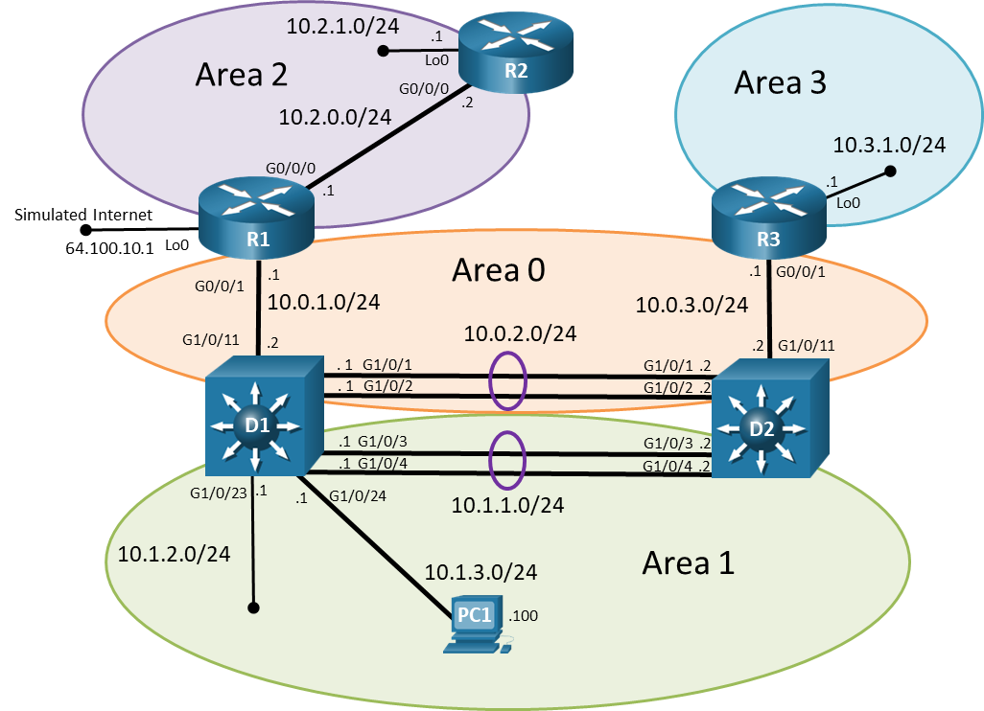

# Addressing Table

| Device | Interface | IPv4 Address | Subnet Mask |
| --- | --- | --- | --- |
| R1 | G0/0/0 | 10.2.0.1 | 255.255.255.0 |
| R1 | G0/0/1 | 10.0.1.1 | 255.255.255.0 |
| R2 | G0/0/0 | 10.2.0.2 | 255.255.255.0 |
| R2 | Lo1 | 10.2.1.1 | 255.255.255.0 |
| R3 | G0/0/1 | 10.0.3.1 | 255.255.255.0 |
| R3 | Lo1 | 10.3.1.1 | 255.255.255.0 |
| D1 | G1/0/1 (Po1) | 10.0.2.1 | 255.255.255.0 |
| D1 | G1/0/2 (Po1) | 10.0.2.1 | 255.255.255.0 |
| D1 | G1/0/3 (Po2) | 10.1.1.1 | 255.255.255.0 |
| D1 | G1/0/4 (Po2) | 10.1.1.1 | 255.255.255.0 |
| D1 | G1/0/11 | 10.0.1.2 | 255.255.255.0 |
| D1 | G1/0/23 | 10.1.2.1 | 255.255.255.0 |
| D1 | G1/0/24 | 10.1.3.1 | 255.255.255.0 |
| D2 | G1/0/1 (Po1) | 10.0.2.2 | 255.255.255.0 |
| D2 | G1/0/2 (Po1) | 10.0.2.2 | 255.255.255.0 |
| D2 | G1/0/3 (Po2) | 10.1.1.2 | 255.255.255.0 |
| D2 | G1/0/4 (Po2) | 10.1.1.2 | 255.255.255.0 |
| D2 | G1/0/11 | 10.0.3.2 | 255.255.255.0 |
| PC1 | NIC | 10.1.3.100/24 | Default Gateway 10.1.3.1 |

# Objectives

Troubleshoot network issues related to the configuration and operation of OSPFv2.

# Background / Scenario

Your University network is using multiarea OSPFv2. The 10.3.1.0/24 network has a single end device which connects to an observatory. Reading the network design documentation, you notice two key items regarding this connection:

* The connection from R3 to the observatory is a microwave link. Because this link can be unstable, it is required to be in its own OSPFv2 area.
* The data from the observatory is sent to an astronomy research team on the 10.1.3.0/24 network (PC1).

Although the topology has a limited number of routers, you should use the appropriate troubleshooting commands to help find and solve the problems in the three trouble tickets as if this were a much more complex topology with many more routers and networks.

You will be loading configurations with intentional errors onto the network. Your tasks are to FIND the error(s), document your findings and the command(s) or method(s) used to fix them, FIX the issue(s) presented here and then test the network to ensure both of the following conditions are met:

* + - * 1. the complaint received in the ticket is resolved
        2. full reachability is restored

**Note**: The routers used with CCNP hands-on labs are Cisco 4221 with Cisco IOS XE Release 16.9.4 (universalk9 image). The switches used in the labs are Cisco Catalyst 3650 with Cisco IOS XE Release 16.9.4 (universalk9 image) and Cisco Catalyst 2960s with Cisco IOS Release 15.2(2) (lanbasek9 image). Other routers, switches, and Cisco IOS versions can be used. Depending on the model and Cisco IOS version, the commands available and the output produced might vary from what is shown in the labs. Refer to the Router Interface Summary Table at the end of the lab for the correct interface identifiers.

**Note**: Make sure that the switches have been erased and have no startup configurations. If you are unsure, contact your instructor.

# Required Resources

* 3 Routers (Cisco 4221 with Cisco IOS XE Release 16.9.4 universal image or comparable)
* 2 Switches (Cisco 3560 with Cisco IOS XE Release 16.9.4 universal image or comparable)
* 1 PC (choice of operating system with terminal emulation program installed)
* Console cables to configure the Cisco IOS devices via the console ports
* Ethernet cables as shown in the topology

# Instructions

## Trouble Ticket 8.1.2.1

Scenario:

Changes were made to minimize the number of routes in area 2. The intention was that all internal OSPF routers in area 2 would only receive a default route via OSPF, and they would not receive any interarea OSPF routes. However, after the change was made users began to indicate that they no longer have connectivity to devices on the 10.2.1.0/24 network.

Use the commands listed below to load the configuration files for this trouble ticket:

| Device | Command |
| --- | --- |
| R1 | **copy flash:/enarsi/8.1.2.1-r1-config.txt run** |
| R2 | **copy flash:/enarsi/8.1.2.1-r2-config.txt run** |
| R3 | **copy flash:/enarsi/8.1.2.1-r3-config.txt run** |
| D1 | **copy flash:/enarsi/8.1.2.1-d1-config.txt run** |
| D2 | **copy flash:/enarsi/8.1.2.1-d2-config.txt run** |

* All routers should have the 10.2.1.0/24 network in their routing tables.
* All area 2 internal OSPF routers should only receive a default route via OSPF, they should not have any interarea routes.
* PC1 should be able to ping 10.2.1.1/24.
* R3, D1, and D2 should see the 10.2.1.0/24 network in their routing table.
* R2 should only have a single OSPF route in its routing table, and that should be a default route learned via OSPF.
* When you have fixed the ticket, change the MOTD on EACH DEVICE using the following command:

banner motd # This is $(hostname) FIXED from ticket <ticket number> #

* Then save the configuration by issuing the **wri** command (on each device).
* Inform your instructor that you are ready for the next ticket.
* After the instructor approves your solution for this ticket, issue the **reset.now** privileged EXEC command This script will clear your configurations and reload the devices.

## Trouble Ticket 8.1.2.2

Scenario:

Recently Layer 3 switch D2 was replaced. However, the backup config file was corrupt and unable to be used. One of the network technicians configured D2 manually using the network documentation including the topology. After D2 was brought online, D2's routing table only sees the 10.3.1.0/24 network via OSPF.

Use the commands listed below to load the configuration files for this trouble ticket:

| Device | Command |
| --- | --- |
| R1 | **copy flash:/enarsi/8.1.2.2-r1-config.txt run** |
| R2 | **copy flash:/enarsi/8.1.2.2-r2-config.txt run** |
| R3 | **copy flash:/enarsi/8.1.2.2-r3-config.txt run** |
| D1 | **copy flash:/enarsi/8.1.2.2-d1-config.txt run** |
| D2 | **copy flash:/enarsi/8.1.2.2-d2-config.txt run** |

* D2 should see all OSPF networks.
* When you have fixed the ticket, change the MOTD on EACH DEVICE using the following command:

banner motd # This is $(hostname) FIXED from ticket <ticket number> #

* Then save the configuration by issuing the **wri** command (on each device).
* Inform your instructor that you are ready for the next ticket.
* After the instructor approves your solution for this ticket, issue the **reset.now** privileged EXEC command. This script will clear your configurations and reload the devices.

## Trouble Ticket 8.1.2.3

Topology Update:

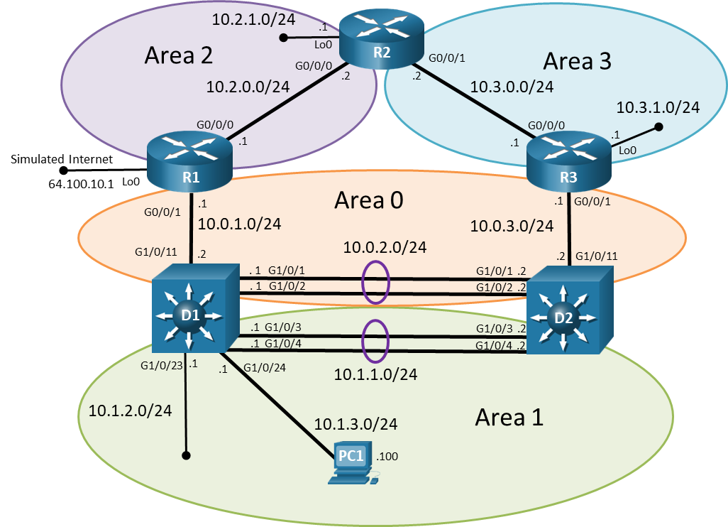

Addressing Table Update:

| Device | Interface | IPv4 Address | Subnet Mask |
| --- | --- | --- | --- |
| R2 | G0/0/0 | 10.2.0.2 | 255.255.255.0 |
| R2 | G0/0/1 | 10.3.0.2 | 255.255.255.0 |
| R2 | Lo1 | 10.2.1.1 | 255.255.255.0 |
| R3 | G0/0/0 | 10.3.0.1 | 255.255.255.0 |
| R3 | G0/0/1 | 10.0.3.1 | 255.255.255.0 |
| R3 | Lo1 | 10.3.1.1 | 255.255.255.0 |

Scenario:

The 10.3.1.0/24 network has a single end device which connects to an observatory. Reading the network design documentation, you notice three key items:

* The connection from R3 to the observatory is a microwave link. Because this link can be unstable, it is required to be in its own OSPFv2 area. The data from the observatory is sent to an astronomy research team on the 10.1.3.0/24 network (PC5).
* For redundancy purposes the design team had installed a new link between R2 and R3. This link results in an additional path from R1 to PC5. The primary path is through D2 to R3. The new backup path is through R2 to R3. This is verified using traceroute.
* Although redundancy is helpful, the most important requirement is that 101.3.0/24 is in its own OSPF area.

A troubleshooting ticket has just been received by the help desk. During construction of a new building on campus, the link between R3 and D2 was cut. It may take four or five days before this link can be restored.

The astronomy team has informed your manager that they are not receiving the data from the observatory and they cannot wait more than a day for the data from the observatory. Your manager is confused about why the data is not being forwarded using the redundant connection via R2.

Your task is to diagnose this problem and resolve it. Connectivity between the 10.3.1.0/24 and 10.1.3.0/24 networks is critical. In addition, the 10.3.1.0/24 network must be in its own area so the unstable link does not affect other areas.

**Note**: OSPF area 2 and area 3 are both normal OSPF areas.

Use the commands listed below to load the configuration files for this trouble ticket:

| Device | Command |
| --- | --- |
| R1 | **copy flash:/enarsi/8.1.2.3-r1-config.txt run** |
| R2 | **copy flash:/enarsi/8.1.2.3-r2-config.txt run** |
| R3 | **copy flash:/enarsi/8.1.2.3-r3-config.txt run** |
| D1 | **copy flash:/enarsi/8.1.2.3-d1-config.txt run** |
| D2 | **copy flash:/enarsi/8.1.2.3-d2-config.txt run** |

**Note**: To simulate the link being cut, shut down the G0/0/1 interface on R3:

R3(config)# **inter g 0/0/1**

R3(config-if)# **shutdown**

* PC1 should be able to ping the 10.3.1.1.
* Network 10.3.1.0/24 must be in its own area.
* When you have fixed the ticket, change the MOTD on EACH DEVICE using the following command:

banner motd # This is $(hostname) FIXED from ticket <ticket number> #

* Then save the configuration by issuing the **wri** command (on each device).
* Inform your instructor that you are ready for the next ticket.
* After the instructor approves your solution for this ticket, issue the **reset.now** privileged EXEC command**.** This script will clear your configurations and reload the devices.

# Router Interface Summary Table

| Router Model | Ethernet Interface #1 | Ethernet Interface #2 | Serial Interface #1 | Serial Interface #2 |
| --- | --- | --- | --- | --- |
| 1800 | Fast Ethernet 0/0 (F0/0) | Fast Ethernet 0/1 (F0/1) | Serial 0/0/0 (S0/0/0) | Serial 0/0/1 (S0/0/1) |
| 1900 | Gigabit Ethernet 0/0 (G0/0) | Gigabit Ethernet 0/1 (G0/1) | Serial 0/0/0 (S0/0/0) | Serial 0/0/1 (S0/0/1) |
| 2801 | Fast Ethernet 0/0 (F0/0) | Fast Ethernet 0/1 (F0/1) | Serial 0/1/0 (S0/1/0) | Serial 0/1/1 (S0/1/1) |
| 2811 | Fast Ethernet 0/0 (F0/0) | Fast Ethernet 0/1 (F0/1) | Serial 0/0/0 (S0/0/0) | Serial 0/0/1 (S0/0/1) |
| 2900 | Gigabit Ethernet 0/0 (G0/0) | Gigabit Ethernet 0/1 (G0/1) | Serial 0/0/0 (S0/0/0) | Serial 0/0/1 (S0/0/1) |
| 4221 | Gigabit Ethernet 0/0/0 (G0/0/0) | Gigabit Ethernet 0/0/1 (G0/0/1) | Serial 0/1/0 (S0/1/0) | Serial 0/1/1 (S0/1/1) |
| 4300 | Gigabit Ethernet 0/0/0 (G0/0/0) | Gigabit Ethernet 0/0/1 (G0/0/1) | Serial 0/1/0 (S0/1/0) | Serial 0/1/1 (S0/1/1) |

**Note**: To find out how the router is configured, look at the interfaces to identify the type of router and how many interfaces the router has. There is no way to effectively list all the combinations of configurations for each router class. This table includes identifiers for the possible combinations of Ethernet and Serial interfaces in the device. The table does not include any other type of interface, even though a specific router may contain one. An example of this might be an ISDN BRI interface. The string in parenthesis is the legal abbreviation that can be used in Cisco IOS commands to represent the interface.

End of document